TASK REPORT

Responsive Product Card Layout
Using CSS Flexbox and Media Queries

1. Objective
To make the product card responsive by displaying the product image and product information side by side on larger screens, and stacking the image above the details when the viewport width is 600 pixels or less.

2. Technologies Used
• HTML for the product card structure
• CSS Flexbox for the horizontal layout
• CSS media queries for responsive behavior
• Chrome DevTools device toolbar for testing the layout at different viewport widths

3. Implementation Summary
The product card uses display: flex and flex-direction: row as its default layout. A media query with max-width: 600px changes the flex direction to column. The image width is set to 100% with automatic height on small screens so it fits the card while preserving its proportions.

4. Responsive CSS
.product-card {
display: flex;
flex-direction: row;
align-items: center;
gap: 20px;
border: 1px solid #ddd;
border-radius: 10px;
padding: 15px;
max-width: 600px;
margin: 20px auto;
}
.product-image {
width: 200px;
height: 200px;
object-fit: cover;
border-radius: 8px;
}
.product-details {
flex: 1;
}
@media screen and (max-width: 600px) {
.product-card {
flex-direction: column;
}
.product-image {
width: 100%;
height: auto;
}
}

5. Testing and Verification
The layout was checked in Chrome DevTools with the viewport set to 600px wide. The media query is active at this width, and the product image is displayed above the product details. The supplied screenshot is included below as the final output evidence.

6. Final Output Screenshot
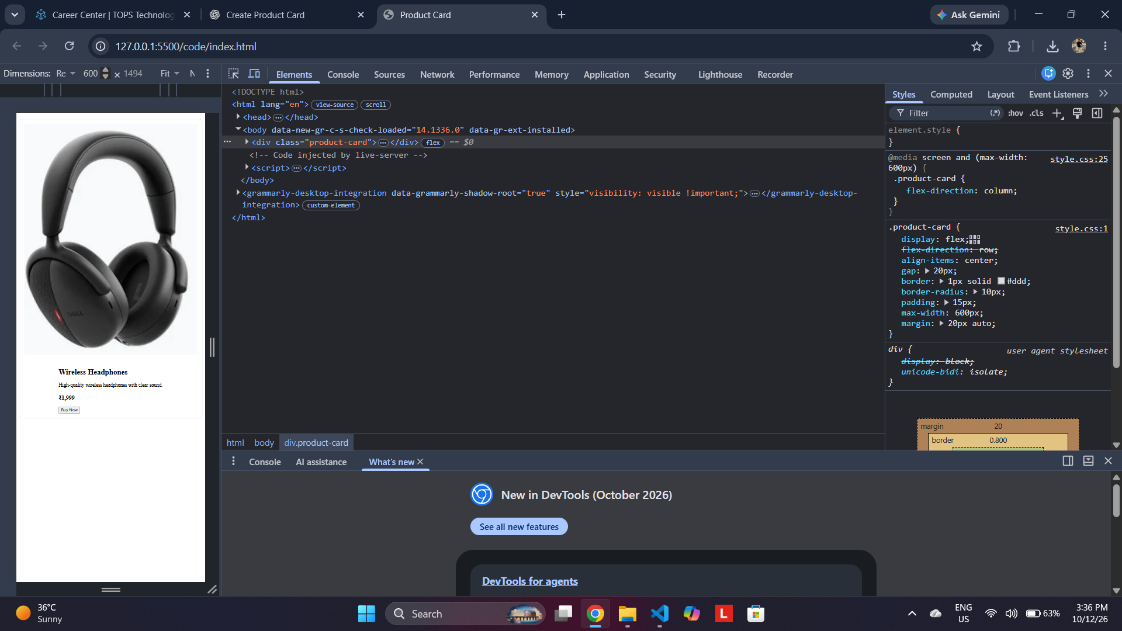
Figure 1. Product card displayed in vertical layout at a 600px viewport width.

7. Conclusion
The responsive product card task demonstrates how CSS Flexbox and a media query can adapt a component to different screen sizes. At widths above 600px, the layout remains horizontal; at 600px and below, it switches to a vertical arrangement. This improves usability on mobile devices and keeps the product image and information easy to view.

